MAKING CANDY BOARDS AND QUILT BOXES

Steps for making a candy board for bees:
- Make the frame: Use scraps of 1 x 3 or 1x4 wood to build a frame the same size as your brood box. It should be at least 2 1/2 inches tall. Attach ½” hardware cloth to the inside of the frame with fence staples. Cut another piece of 1 x 3 and nail into the middle of the box for support.
- Prepare the sugar mixture: In a large bowl, pour in 10 lbs. of sugar and gradually add 10 ounces of water. You can also add 1 tablespoon of vinegar or honey-b-healthy to the water before mixing. Moisten the sugar until looks like sand and holds together.
- Line the frame: Line the inside of the frame with newspaper, tissue paper, or waxed paper.
- Pour in the mixture: Pour the sugar mixture into the frame, spreading it evenly and leaving an opening in the middle of the box. Pound it down to pack the sugar together.
- Let it harden: Place the candy board somewhere with ventilation underneath. and let the sugar harden.
- Install the board: When the candy has hardened, install the board in the hive just above the brood box. You can put the board in later in the season when it's colder and the bees are less likely to break cluster. If you put it in too early, they might eat the sugar on warmer days. For added sustenance, you can also include pieces of pollen patties in the board.

Here are some steps for making a quilt box for bees:
- Make the frame: You can use scraps of 1 x 3 or 1x4 wood to build a frame that's at least 2 1/2 inches tall. Drill ventilation holes on the ends and sides for the moist air to escape. Attach screen wire or thin cloth to the underside of the frame and staple into place.
- Fill the box with absorbent material like wood shavings. This box serves as moisture control and insulation. Install the box on top of the candy board. No need for the inner cover, but if you don’t know where to store it just leave it on.

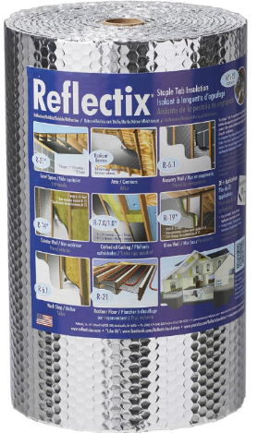

For extra insulation, cut a piece of reflective bubble insulation the size of the quilt box. Install in December.

How to Make a Quilt Box for Bees: A Comprehensive Guide | BeeKeepinglove.com

How to Make a Bee Quilt Box for Your Hive - Carolina Honeybees

How To Make A Beehive Quilt Box [Moisture Control For Bees] | Beekeepingstudy

How to make candy boards (and candy cakes) for bees - Honey Bee Suite

DIY Candy Board for Bees: No Cook- Carolina Honeybees

