Organic Honey and...

As we round out the summer, we have filled pollination contracts; moved our hives for better forage and more honey production; moved our hives to fulfil other pollination contracts; many have extracted some multiple times; treated at least once and been contacted to get involved in some industry related research.

As I’m talking to a lot of beekeepers that stop by our booth, I’ve been asked what we are doing for beekeepers specifically those that want to sell Organic Honey?

Last week while in Washington, D.C. we met with Erin Morris, Administrator and Jennifer Tucker, Ph.D., Deputy Administrator, and Andrew Malone, Associate Deputy Administrator for Agricultural Marketing Service, National Organic Program. Our conversation started with “U.S. Domestic beekeepers are losing out on a market that would allow us to sell honey for a premium
because there is not Standard for U.S. Organic Honey”.

Imagine our surprise when the answer we received from Jennifer was
“There is a standard for U.S. beekeepers to sell Organic Honey.” She explained that to get certified for Organic Honey in the U.S., one needs to follow the organic standards for Livestock in 7 CFR 205, sections 205.236 through 205.242. Some provisions will be more relevant to beekeeping than others. Note that organic is not just foraging for your bees: it is treatment, feed and feed supplements, and record keeping to prove you followed the standards. This requires close attention to anything you add to the hive whether you have supers on or not. It is not easy, but doable.

If you are interested in selling Organic Honey certified by the USDA, both the process (handling) and husbandry (management) of the hives can be certified.

Each location must be certified by a certifying agent. There are two certifiers that are actively certifying organic beekeeping operations in the United States: CCOF Certification Services and Where Food Comes From Organic. Jennifer and Andrew contacted them to make sure both certifiers were ready to accept and evaluate applications for domestic honey operations.

Other notes of interest:
- We met with senior staff members of the USDA/APHIS. They have mothballed the project of introducing a biological to control Chinese Tallow. Their comment was “We listened to the Beekeepers”
- Improve Beekeeper Access to Federal Public Lands. We met with senior management staff of the U.S. Forest Service who listened to our concerns about losing this access. With the assistance of ARS, documents have been sent to them to dispute the claims that honey bees are not native to the U.S., honey bees pass viruses to native bees, and honey bees out compete for resources of native bees. This has resulted in 2 contracts being issued to beekeepers in the last 30 days in the Western states.
There were many other groups we met with as well over industry issues.

Please feel free to contact me if you have any questions or concerns. seibshoosierhoney@yahoo.com or 317-432-9578

Debbie Seib, ABF President

Scholarship Applications

2027 Graduate Scholarship Applications Now Open

The Foundation for the Preservation of Honey Bees is accepting applications for four $5,000 graduate scholarships. Eligible students must be studying honey bees, bee husbandry, or the apiculture industry.

Application deadline: September 18, 2026

Click Here to View scholarship details and application requirements

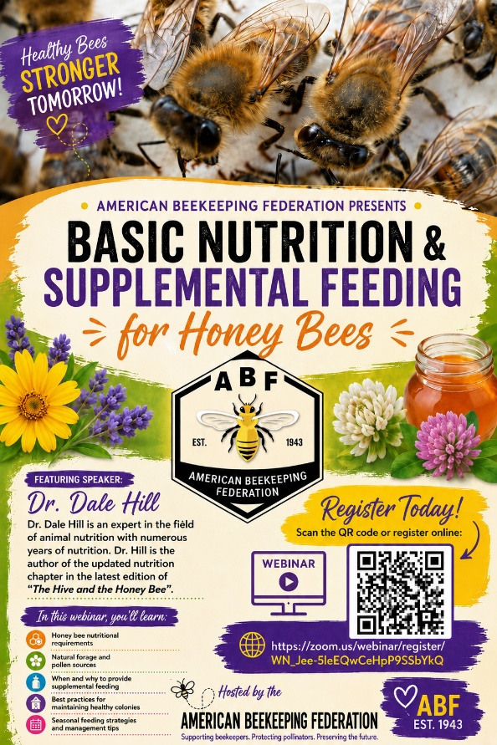

From Research to the Apiary: Practical Takeaways from the Latest National Honey Board's Honey Bee Health Studies

In our last update, we highlighted the National Honey Board's continued investment in honey bee health research through Project Apis m. This work supports scientists across the country who are tackling some of the biggest challenges facing beekeepers, from emerging pests and pathogens to nutrition and colony management.

While many of these projects are still underway, several are already providing valuable insights that can help shape future management practices and identify promising new tools for beekeepers.

Protecting colonies from pests and diseases remains a major focus. Dr. James Nieh and his team at the University of California San Diego are studying immune priming in queens as a possible strategy to reduce the impacts of Vairomorpha (Nosema) ceranae, while Dr. Brandon Hopkins at Washington State University is evaluating new fumigation methods to safely sterilize comb and reduce disease transmission within commercial operations.

Additional research is focused on strengthening overall colony management. Dr. Lewis Bartlett at the University of Georgia is investigating new approaches for managing small hive beetle risk while providing supplemental pollen and protein feeding to improve colony health.

At the same time, researchers continue to investigate improved methods for detection and management of Tropilaelaps mites before they reach the United States. Dr. Jeff Pettis is evaluating organic acids as potential tools for both detection and control, helping prepare the industry with practical management options should these mites arrive.

Although these projects address different aspects of honey bee health, they share a common goal: providing beekeepers with practical, science-based solutions that improve colony survival, strengthen management decisions and support the long-term sustainability of the industry.

To learn more about these projects and follow their progress, visit the Bee Health Collective at beehealthcollective.org.

