Welcome to Beekeeping in August!

What To Look For
- Brood Pattern: Inspect the brood pattern for consistency and density. Spotty brood patterns may indicate problems such as disease or a failing queen.
- Population Assessment: Make sure your hive has a strong population. The bees need to be numerous enough to collect resources and maintain hive temperature.
Pest Management
Varroa mites
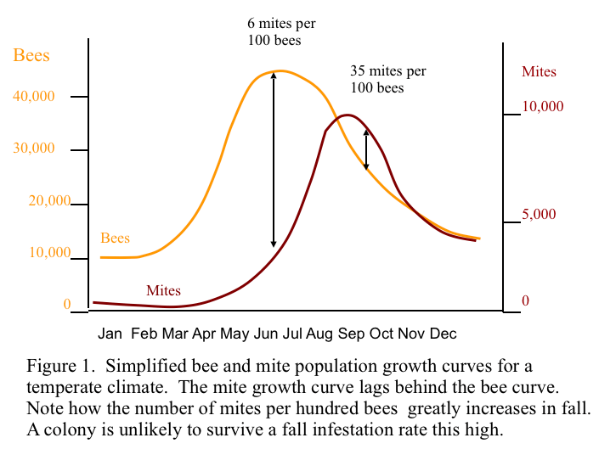
August is a critical time for managing Varroa populations.
Above is from Randy Oliver’s article https://scientificbeekeeping.com/varroa-management/
Choose treatments that are suitable for the current weather conditions and colony health.

Check out Honey Bee Health Coalition for what to use.
https://honeybeehealthcoalition.org/resources/varroa-management/
https://cantilever-instruction.com/varroatool/story_html5.html
Small Hive Beetle
- Larvae burrow and tunnel through comb, piercing and damaging the wax comb and cell caps.
- Larvae eat honey, pollen and live honeybee brood (eggs, larvae and pupae).
- Larvae defecate in the honey causing it to ferment, froth and weep from the cells. The fermenting honey has an odor of decaying oranges. A combination of fermenting honey, SHB secretions and excrement result in a slime on the combs and other components in the hive. Contaminated honey is unsuitable for sale and unacceptable to bees as bee food.
- Honeybee queens may stop egg laying and the number of adult bees in the hive may quickly fall.
- The honeybee colony may leave when SHB infestations are heavy and slime is present.
- Combs of honey removed from hives and put aside for extracting at a later time may be ruined.
- Stored combs, beeswax capping, section comb honey and bee collected pollen are prone to infestation. Newly drawn combs appear to be more easily damaged than older brood combs that have been toughened by several layers of honeybee pupal skins.
Threat Level | Observations | Recommended Action
Normal | A few adult beetles under the lid or on the periphery. | Continue regular monitoring; no immediate action needed.
Warning | Beetles moving freely across the honeycomb. | Strengthen the colony; check for low bee density.
Critical | Presence of larvae (slimy worms) and fermented honey. | Immediate physical removal of slime and intervention.
Prevention | Unguarded pollen patties or large food stores. | Feed smaller portions; maintain high worker bee density.
https://honestbeeltd.com/faqs/when-should-a-beekeeper-become-concerned-about-the-presence-of-small-hive-beetles
Wax Moth
- Wax consumption: Larvae eat beeswax, pollen, cocoon silk, and bee waste, ruining the structural integrity of the comb.

- Webbing and tunnels: Caterpillars spin tough, silky webs as they tunnel through cells, which ruins honey and brood frames.

- Chewing wood: Greater wax moth larvae chew deep grooves or "cocooned cavities" into wooden and polystyrene frames and hive bodies before pupating.

- Galleriasis: Heavy webbing traps emerging with bee pupae inside their cells, stopping them from getting out.

- Bald brood: Larvae chew away brood cappings, causing worker bees to tear open the rest of the cap and exposing pupae, which can result in deformed wings and legs.
Focus your check on the top bars, inner covers, and edges where bees cannot easily patrol
- Fine silk threads spun across the honeycomb surface and inside the cells as larvae crawl and hide.

- Chewed and broken wax with irregular holes, plus bald brood patterns where bees uncapped cells to reach hidden pests.

- Small, dark, cylindrical pellets resembling tiny grains of sand or pepper on the bottom board.

- Tough, white, boat-shaped cocoons tucked firmly into corners of frames or chewed into the wooden walls of the hive.
Feeding and Resources
- Make sure this is plenty of water available.
- If you haven't already, August can be a time to harvest honey, ensuring you leave enough for the bees to overwinter.
Hive Maintenance
- Ensure your hives have adequate ventilation to prevent overheating and reduce humidity.
- Inspect and repair any beekeeping equipment to ensure it is ready for the upcoming months.
- Begin planning for winterizing your hives.

