PLANTING FOR POLLINATORS WITH A FOCUS ON BEES

9/1/2020 Julie Wells .

Note: links to articles mentioned, various plant lists, and other resources are at the bottom of this document.

Some of you are not avid gardeners and may think you don’t care, but as beekeepers, we should be concerned about plants for various reasons:
- the health of honey bees, of course
- a surprising sentiment against honey bees because they (supposedly) compete with native bees – we need to find ways to deal with this growing sentiment; otherwise, we may see reversals of the support for beekeeping
- the future of crops and the environment in general – as you probably know, most bee populations have declined dramatically, endangering our own food supply and indicating other environmental dangers

As an avid gardener, I hear a lot about the increasing push to plant plants which are native to the region. Native plants are generally the best bet for a high amount of pollen, for being non-invasive, and for more likely being pollinator hosts (butterfly caterpillar food).
This is because native plants developed naturally in tandem with the area’s pollinators and were not bred just to be pretty.
The problem with invasives, besides creating extra work in the garden, is crowding out beneficial plants, and so threatening wildlife food supply and habitat.
But do your research, read the plant tags, AND look online, checking more than one site.
- Sometimes plants which are not native are fine, it’s just that natives are generally the safest bet for pollinators and avoiding problems.
- Sometimes so-called natives are native to the U.S., but not to your area (and may even be invasive in your area).
- Cultivars of natives aka “nativars” are often not as beneficial as the original species.

An example where research helped me: the much-loved butterfly bush is now controversial due to being invasive and not being a host for any pollinator. However, they are quick to grow, provide pollen to bees, butterflies, and hummingbirds – and are beautiful.  …My research indicates that they ARE very invasive in some regions, but apparently not here. They are not on the Indiana list of invasive plants.  …An article by The Spruce¹ gives a great objective analysis of the entire controversy: 1) this plant is not invasive everywhere; 2) the argument regarding not being a host is valid, but with a diversity of plants, it’s not a huge objection. …So, since I have a large diversity of plants, I am not | 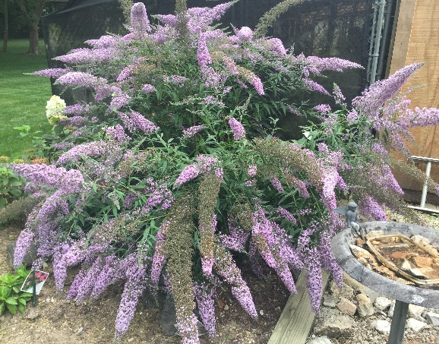
going to worry about my butterfly bush, unless I learn that it has become invasive here.
(Plants which are not invasive now can become invasive with changing conditions.)
Planting for honey and native bees – summarized from DNR Gardening for Honey Bees², The Honeybee Conservancy Plant a Bee Garden³, and The Spruce How to Attract Bees and Other Pollinators to Your Garden⁴ :
- Plant flowers in clumps. Flowers clustered into clumps of one species will attract more pollinators than individual plants scattered through the habitat patch⁴. This is especially true for honey bees². Where space allows, make the clumps four feet or more in diameter.⁴ (Note: coneflower is one example of a native plant, beautiful in clumps.)
- Plant for all seasons, with a succession of overlapping blooming from spring to fall.^{2,3,4} Plant at least 3 different type of flowers per season.³ Most bee species feed on a range of plants through their life cycle. With several plant species blooming at once and a sequence of plants flowering through spring, summer, and fall, you can support a range of bee species that fly at different times of the season⁴ and prefer different flowers. Note: In our area, hellebores (Lenten Rose), crocus, and snowdrops bloom in late Winter.
- Provide diversity.^{2,4} Select plants that will provide pollen as well as nectar.² Don’t forget trees and shrubs that can provide pollen and nectar.² Some shapes may be preferred by only some bees.
- Skip highly hybridized plants. These have been bred to not seed and so produce very little pollen.³ You will have to pay attention when purchasing.
- Use local native plants. Research suggests native plants are four times more attractive to native bees than exotic flowers. They are also usually well adapted to your growing conditions and can thrive with minimum attention. In gardens, heirloom varieties of herbs and perennials can also provide good foraging.⁴ (See the plant lists; some include several herbs – you just need to let part of your herbs go to seed.)
- Plant where bees will visit. Bees favor sunny spots over shade and need some shelter from strong winds.⁴
- Rethink your lawn. Replace part of your grass with pollinator plants and habitat.³ Herbicides may kill plants that bees get pollen and nectar from (like dandelions and Dutch white clover). So, don’t go for that perfect lawn with no weeds.²
- If possible, do not use pesticides.^{2,3,4} Most pesticides are not selective, killing beneficial bugs along with the pests. If you must use a pesticide, start with the least toxic one and follow the label instructions to the letter³ or use natural pesticides⁴.
- Provide a water source. A shallow container of water with pebbles or twigs to land on while drinking.³ My girls come to my birdbath, which has enough flatness on its rim.
- Leave or make homes for native bees.³
- Leave a patch of garden in a sunny spot uncultivated for native bees that burrow.
- Some native bees also need a soil surface for nesting.
- Others need piles of branches, bamboo sticks, hollow reeds.
<Artificial mason bee houses must have reeds replaced, need cleaning, and are often not deep enough. Usually a natural wood or reed pile is better. Lifehacker has a good article⁵ about mason bees and artificial houses.>
- Mason bees need a water source and mud.
- Many bees are attracted to weedy, untended hedgerows.
For plant traits that attract bees, look for:
- Flower color – Bees have good color vision to help them find flowers and the nectar and pollen they offer.⁴ Flower colors that particularly attract bees are blue, purple, violet, white, and yellow.^{2,4}
- Flower shape – varied for different bee preferences.^{2,3,4} Not double-blooms, which produce much less nectar and make it hard for bees to access pollen.^{2,3} There are four thousand different species of bees in North America, and they are all different sizes, have different tongue lengths, and will feed on different shaped flowers. Consequently, providing a range of flower shapes means more bees can benefit.⁴
- Nectar guides being present – markings or patterns that guide bees into the plant.²
- Nectar being present – there is usually a fresh, mild, and pleasant smell.²
- Pollen – it’s often sticky and scented.²

The articles have more advice and plant lists. (See links at the bottom.)

- -
Be aware, as of April 2019, there is a list of plants which are illegal to sell or move in Indiana. Even giving a start to a friend is illegal. Avoid these plants, but if you already have them, you are allowed to keep them.

Dame’s Rocket is an old-time favorite which is on the list. I got this plant from my grandmother and do not intend to get rid of it, but I won’t give any away or donate to my garden club’s annual sale. It doesn’t spread in my garden, but it must be very bad somewhere in Indiana. | 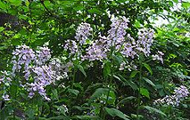 | Dame’s Rocket looks similar to tall phlox but blooms earlier and has 4 petals instead of 5.

Most plants on this list are more obviously invasive. I don’t know the penalties, but we should support this regulation on principle. A link to the list is at the bottom of this article.

- -
How can we deal with the claims that honey bees are bad for native bees due to competition? Honey bees are said to crowd out native bees. There are a lot of conflicting statistics on which is the better pollinator. Native bees are claimed to be much better pollinators, just not available to place in large numbers in orchards and crops. The majority of the honey bees’ claim to higher pollination is from almond orchards in California.

Article “Do Honey Bees Compete with Native Bees?”⁶ on the Habitat Network website analyzes foraging, disease, biodiversity – and planting natives. It shows that they have differences and having BOTH is the most beneficial:

- Farmers who increased the diversity of foraging areas increased both honey and native bee populations. (Grasslands, wetlands, and forest in the same area.)

- Where native and honey bees live and pollinate side-by-side, overall fruit-set is improved, when compared to similar fields having only honey bees or only native bees.
The reason is probably linked to subtle differences in feeding behavior.

- In fields with increased pollination from having both native and honey bees, the honey bees pollinate the mass flowering areas, while native bees specialize in out-of-the-way blooms and very early or very late blooms.

  - Honey bees prefer LOTS of flowers in ONE area. They gravitate towards plants that are loaded with flowers, and feed until the pollen and nectar are depleted.
Note: It doesn’t always have to be one big plot; I have several smaller patches of cleome near each other, and the honey bees find them. It seems that any flowers available when dearth begins get visited more. One small clump of Garlic Chives will be found by honey bees. Note, cleome and garlic chives are not native but are very common in central Indiana; they do seed heavily.
Some exceptions (but a large patch is still best for Honey Bees)  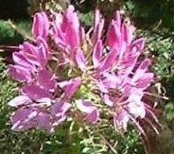. | 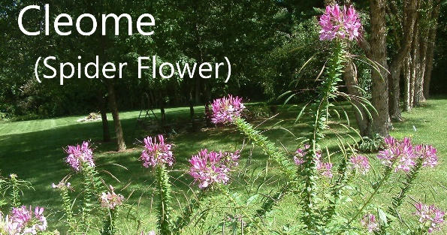 | 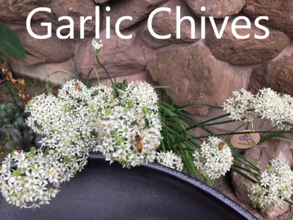 | These do  throw seed

  - Native bees visit flowers regardless of flower density. They find both big and small patches.

- Evidence shows that native bees avoid areas where honey bees gravitate, possibly because honey bees can be more aggressive and territorial. I’d say this is not always true.
Not always true. I see no aggression or avoidance in my large sedum patch, where both honey and native bees (and butterflies) are abundant. Perhaps they mean very large areas, such as orchards? – No, see the link to Orchard Pollination: Wild Bees.⁷ Note, sedum is not native but very common in our area. It thickens but doesn’t throw seed – these take virtually no care.
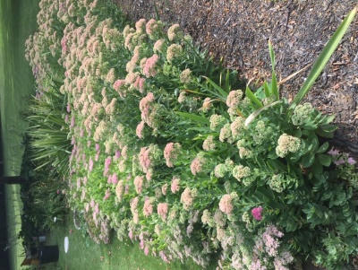 | 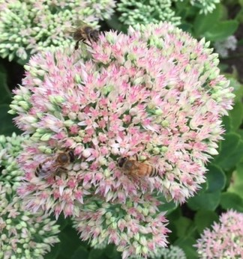 | 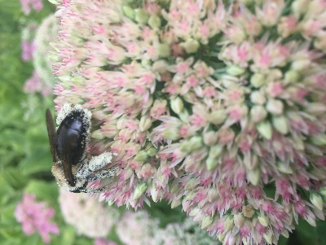 | 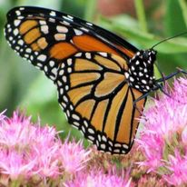

Regardless, the presence of both honey and native bees maximizes overall pollination.

- In urban environments, honey bees were more likely to be in gardens, wild bees in green spaces and less developed parts. Both are vital to urban pollination.

- Some bees cannot reach the pollen or nectar of certain flowers due to their anatomy. Those which can’t be accessed by honey bees reduce competition with other bees.
One example: I had looked forward to the girls visiting my 15’ x 6’ plot of tall phlox, but I quickly learned that they can’t get to the nectar in these blossoms due to the long, slender tube behind the flat petals. So, this is a spot that favors native bees.

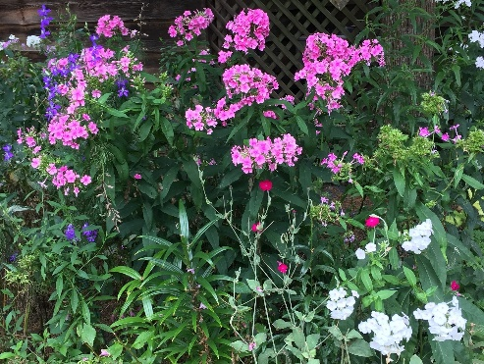 | <- The pink and white blooms are phlox. This is only a small part of the phlox located here. Many pollinators visit these, but honey bees haven’t.  (The dark purple is larkspur. The small magenta blooms are rose campion.)  Note the long taper  behind the petals. -> | 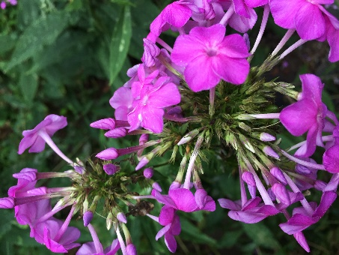

- Direct competition between honey bees and bumblebees can result from landscapes where many of the flowers are similar. In one study, honey bee hives were added to areas where bumblebee populations were present. In these areas with few kinds of plants, honey bees out-competed bumblebees. In the areas with a diversity of plants, this was not true.

- Honey bees and most or all other bees are sensitive to pesticides, particularly neonicotinoids aka neonics.

- Honey bees can pass disease. Research on the impact to wild bees is still limited. Deformed Wing Virus (caused by varroa mites) has been passed to some wild bees. Nosema ceranae (parasite) has been passed to bumblebees. (Nosema bombi is thought to be passed from escaped greenhouse bumblebees to wild bees.)

- To help all bees: create diverse native landscapes, eliminate the use of pesticides, spread the word to neighbors and communities that with their properties, they can be a part of the solution for our struggling bee populations – and, be able to respond to anti-honey-bee comments. You might want to read the article for your own knowledge or ammunition for anti-honey-bee discussions.
- -
My response to the bee competition controversy and the push to grow native plants will be:
- Having both honey and native bees provides the most total pollination. We need both to maintain our food supply.
- Lean toward native plants, but some non-natives are OK as long as you provide nectar, pollen, and host plants – and avoid invasive plants.
- Plant diversity overcomes competition problems and benefits all bees. Provide flowers which honey bees like and some they don’t. Provide large patches of single plants for honey bees, and patches of varied blooms for the native bees. Provide very early and very late blooms for native bees, which can forage in colder temperatures.
- Everyone should reduce or eliminate pesticide use.
- Beekeepers work hard to fight disease.

See next page for plants lists and other links.
Plant lists or articles including plant lists:
Good for Pollinators
- Gardening for Honey Bees pp. 2-5 (indicates nectar or pollen)
https://www.in.gov/dnr/entomolo/files/ep-Gardening_for_Honey_Bees.pdf
- 21 Flowers That Attract Bees https://thehoneybeeconservancy.org/2017/03/27/21-flowers-that-attract-bees/
- Recommended Indiana-native Plants for Attracting Pollinators

https://extension.entm.purdue.edu/publications/POL-6/POL-6.pdf
- How to Attract Bees and Other Pollinators https://www.thespruce.com/bee-plants-1401948
- The Best Plants to Attract Bees https://www.thespruce.com/best-plants-to-attract-bees-4142007
- Want to Feed the Bees? Plant a Bee Tree http://www.greengardenbuzz.com/good-bee-trees/
- Native Plant Insect Interactions (scroll down; shows WHICH bees, not just “Bees”)

https://www.prairiemoon.com/PDF/Prairie-Moon-Holm.Native-Plant-Insect-Interactions.pdf
- A list of various Midwest/Great Lakes Plant Lists https://www.xerces.org/pollinator-resource-center/great-lakes
Invasive
- DNR and Federal illegal / regulated invasives https://www.in.gov/dnr/6351.htm

Mentioned articles:
- The Spruce – Butterfly Bush Plants - Magnets for Swallowtails, Monarchs, Controversy
https://www.thespruce.com/butterfly-bush-plants-magnet-for-swallowtails-controversy-2130863
- Indiana DNR – Gardening for Honey Bees
https://www.in.gov/dnr/entomolo/files/ep-Gardening_for_Honey_Bees.pdf
- The Honeybee Conservancy “Plant a Bee Garden”
https://thehoneybeeconservancy.org/plant-a-bee-garden/
- The Spruce – How to Attract Bees and Other Pollinators to Your Garden
https://www.thespruce.com/bee-plants-1401948
- Lifehacker – How to Correctly Set Up A Mason Bee House (including info about Mason Bees)
https://lifehacker.com/how-to-correctly-set-up-a-mason-bee-house-1834551902
- Habitat Network – Do Honey Bees Compete with Native Bees?
https://content.yardmap.org/learn/honey-bees-compete-native-bees/
- Penn State – Orchard Pollination: Wild Bees https://extension.psu.edu/orchard-pollination-wild-bees

Other good resources:
- INPS Indiana Native Plant Society https://indiananativeplants.org/
- Treehugger – Neonicotinoids: What Gardeners Need to Know
https://www.treehugger.com/neonicotinoids-what-home-gardeners-need-to-know-4863832
- Treehugger – Insects - Get to Know the pollinators & other beneficial insects who can be your allies in the Garden
https://www.treehugger.com/insects-4846049
- Book Nature’s Best Hope – A New Approach to Conservation That Starts in Your Yard by Doug Tallamy
“We need functioning ecosystems to produce what we call 'ecosystem services' that support humans. It’s not an option to lose our pollinators, it’s not an option to mess up our watersheds and to not have viable food webs that support all the other animals" said Tallamy. "So, we need to build landscapes that do all those things.”
LINK TO ARTICLE: https://www.delawarepublic.org/post/ud-professor-pens-new-book-called-natures-best-hope
- Xerces Society http://www.xerces.org/
- Type “gardening for bees” in your browser’s search field to find more articles and sites
- For other pollinators, search for “gardening for butterflies” or “gardening for hummingbirds”
- Facebook - type “Pollinator Friendly” in the Search field on Facebook to find a few groups
- Our own Facebook “Indy Southside Beekeepers”

